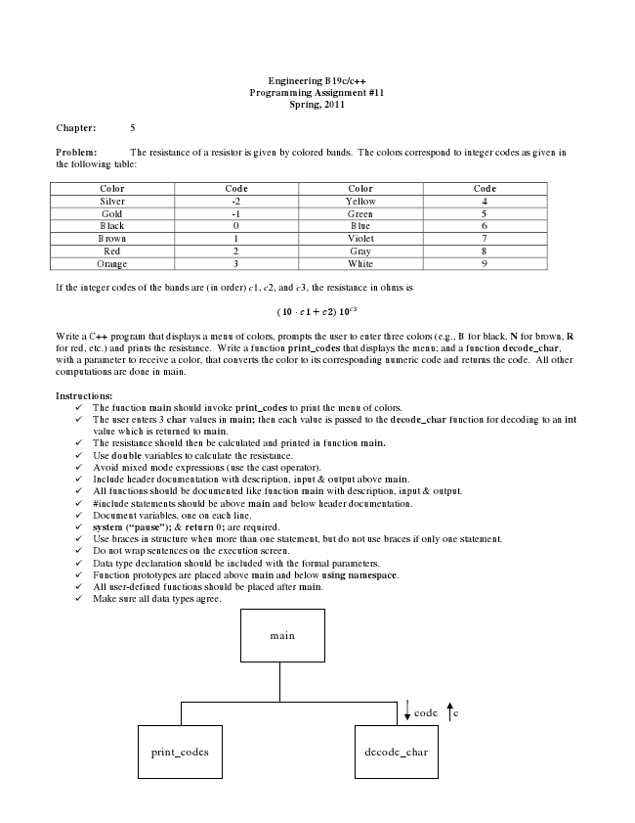

**Engineering B19c/c++ Programming Assignment #11 Spring, 2011**

**Chapter: 5**

Problem: The resistance of a resistor is given by colored bands. The colors correspond to integer codes as given in the following table:

Color Code Color Code Silver -2 Yellow 4 Gold -1 Green 5 Black 0 Blue 6 Brown 1 Violet 7 Red 2 Gray 8 Orange 3 White 9

If the integer codes of the bands are (in order) c1, c2, and c3, the resistance in ohms is

(10 ∙ 1 + 2)10

Write a C++ program that displays a menu of colors, prompts the user to enter three colors (e.g., B for black, N for brown, R for red, etc.) and prints the resistance. Write a function print_codes that displays the menu; and a function decode_char, with a parameter to receive a color, that converts the color to its corresponding numeric code and returns the code. All other computations are done in main.

**Instructions:**

✓ The function main should invoke print_codes to print the menu of colors. ✓ The user enters 3 char values in main; then each value is passed to the decode_char function for decoding to an int

value which is returned to main. ✓ The resistance should then be calculated and printed in function main. ✓ Use double variables to calculate the resistance. ✓ Avoid mixed mode expressions (use the cast operator). ✓ Include header documentation with description, input & output above main. ✓ All functions should be documented like function main with description, input & output. ✓ #include statements should be above main and below header documentation. ✓ Document variables, one on each line. ✓ system (“pause”); & return 0; are required. ✓ Use braces in structure when more than one statement, but do not use braces if only one statement. ✓ Do not wrap sentences on the execution screen. ✓ Data type declaration should be included with the formal parameters. ✓ Function prototypes are placed above main and below using namespace. ✓ All user-defined functions should be placed after main. ✓ Make sure all data types agree.

main

code c

print_codes decode_char